**Kickstart Campaign Report**

1. Given the provided data, what are three conclusions we can draw about Kickstarter campaigns?
   1. Between 2009 and 2017, Kickstarter campaigns launched in the first half of the year have been on the whole, more successful than those launched in the second half of the year. Possible implications of this include:
      1. Projects do not gain enough attention/funding in the second half of the year, as people are focused on other activities/spending, like summer trips and Thanksgiving/Christmas holidays.

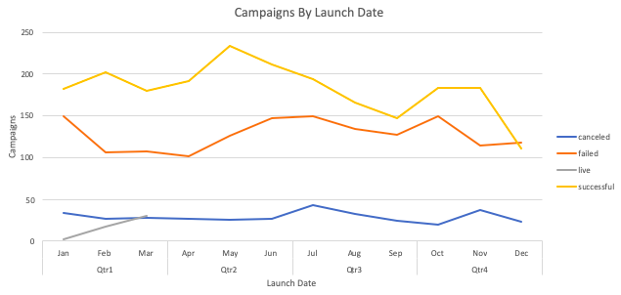

* 1. Between 2009 and 2017, the most successful Kickstarter campaigns had to do with rock music and technology/hardware, both with 100% success rates.
     1. It seems as though people like to contribute to projects that have a clear end product/event. People are more likely to back a project they can enjoy themselves.

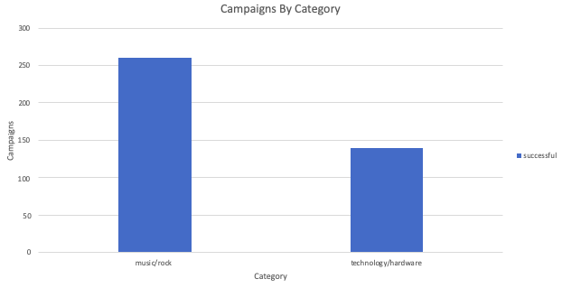

* 1. Continuing on the point mentioned above, the highest number of campaigns were for theater and film projects.
     1. Kickstarter seems to be an effective platform to gain funding for multimedia projects that traditionally have limited ways of getting funding.
     2. Both theater and film projects also have high success rates (65% and 58%, respectively), indicating that people are willing to back projects they can see the end product of.

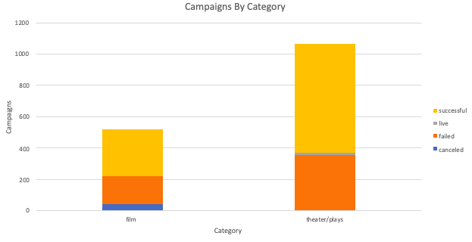

* 1. Campaigns with a subcategory of podcast, documentary, short, and television also had a 100% success rate, compared to other forms of video such as animation and drama. This seems like funding is more successful for projects that usually require a lower budget.



* 1. From the bonus portion of the assignment, it is clear that there are diminishing marginal returns for the size of the goal.
     1. The larger the amount is, the lower the chances of being successful.
     2. The sweet spot for campaigns is between $1k-$5k.
     3. The one exception to this is for campaigns with a goal amount greater than $50k. This indicates that very large campaigns with a purpose or more meaningful end result may attract more backers.



1. What are some limitations of this dataset?
   1. The data is only for campaigns between 2009-2017. Other trends may exist now.
   2. The data has campaign launch date and campaign due date, but it does not have the date that successful campaigns reached their goal. This could be helpful for determining if certain campaign categories have a higher success velocity.
   3. Additional location information could be used. Country seems to reference where the campaign was launched, but it would be interesting to know the countries that backers are contributing from.
2. What are some other possible tables and/or graphs that we could create?
   1. Campaign success rate by staff pick vs. non-staff pick
   2. Campaign success rate by spotlight project vs. non-spotlight project
   3. Campaign backers by category and subcategory
   4. Average backer contribution by campaign category and subcategory
   5. Average back contribution by campaign country